

AI BASED CROP DISEASE DETECTION SYSTEM
A CAPSTONE PROJECT REPORT
Submitted in partial fulfilment for the Course of
CSA1711 – ARTIFICIAL INTELLIGENCE
to the award of the degree of
BACHELOR OF ENGINEERING
IN
Information technology

Submitted by
S. ROOBINI (192421114)

Under the Supervision of
Dr. Krishna Kumar Kathiresan

SIMATS ENGINEERING
Saveetha Institute of Medical and Technical Sciences
Chennai-602105
SEPTEMBER 2026

SIMATS ENGINEERING
Saveetha Institute of Medical and Technical Sciences
Chennai – 602105
BONAFIDE CERTIFICATE

This is to certify that the Capstone Project entitled “AI Based Crop Disease Detection System” has been carried out by S. Roobini (192421114) under the supervision of Dr. Krishna Kumar Kathiresan and is submitted in partial fulfilment of the requirements for the current semester of the B.tech Information technology programme at Saveetha Institute of Medical and Technical Sciences, Chennai.
COURSE COORDINATOR COURSE FACULTY
Dr. KrishnaKumar Kathiresan Dr. Krishna Kumar Kathiresan
Professor Professor
Generative AI Generative AI
SIMATS Engineering, SIMATS Engineering,
SIMATS, Chennai – 602105. SIMATS, Chennai – 602105.

Submitted for the Project work Viva-Voce held on 07-09-2026

INTERNAL EXAMINER EXTERNAL EXAMINER

SIMATS ENGINEERING
Saveetha Institute of Medical and Technical Sciences
Chennai-602105
DECLARATION
I, S. Roobini (192421114) of the Department of Computer Science and Engineering, SIMATS Engineering, Saveetha Institute of Medical and Technical Sciences, Chennai, hereby declare that the Capstone Project Work entitled “AI Based Crop Disease Detection System” is the result of our own bonafide efforts. To the best of our knowledge, the work presented herein is original and has been carried out in accordance with engineering ethics and academic integrity. External sources, datasets, software, and AI-assisted resources used in the project have been acknowledged appropriately.
Place: Chennai
Date: 07/09/2026

Signature of Students with Names
S. Roobini

SIMATS ENGINEERING
Saveetha Institute of Medical and Technical Sciences
Chennai-602105
INDIVIDUAL CONTRIBUTION STATEMENT
Table 1. Individual contribution statement
Student / Register No. | Specific Responsibilities | Design & Development | Testing & Analysis | Report Contribution | Approx. Contribution
S. Roobini / 192421114 | Documentation and evaluation support | System documentation and integration support | Comparison, analysis and validation | Chapter 5, references and formatting | 33%
Total |  |  |  |  | 100%

ABSTRACT
ABSTRACT
Crop diseases are a major agricultural problem because delayed identification can reduce crop yield, quality, and farmer income. Traditional diagnosis mainly depends on manual inspection and expert knowledge, which can be time-consuming, difficult to scale across large fields, and affected by human error. This project presents an AI-based crop disease detection system that analyzes plant-leaf images and predicts whether a crop is healthy or affected by a selected disease. The proposed approach uses image acquisition, preprocessing, dataset organization, convolutional neural network (CNN) training, classification, and result presentation through a user-friendly web interface. The supplied implementation also demonstrates prediction history and disease information so that users can review previous results. The model-development workflow includes image resizing, normalization, training/validation splitting, CNN feature extraction, softmax classification, and evaluation using accuracy, precision, recall, and F1-score. The reported comparison shows the proposed CNN achieving 96.5% accuracy, 95.0% precision, 95.8% recall, and 95.3% F1-score in the project evaluation, outperforming the compared SVM, Random Forest, KNN, and Decision Tree models on the displayed metrics. The implemented interface demonstrates image upload, analysis-result presentation, disease information, and prediction history. The system therefore provides a practical foundation for early crop disease identification and can be extended with larger datasets, mobile deployment, IoT sensing, cloud processing, and disease-severity estimation.
Keywords: Artificial Intelligence, Crop Disease Detection, Convolutional Neural Network, Image Processing, Computer Vision, Smart Agriculture

TABLE OF CONTENT
Sl. No. | Title | Page
I | Certificate from the Supervisor | ii
Ii | Declaration by the Candidate | iii
iii | Individual Contribution Statement | iv
iv | Abstract | v
v | List of Figures | vi
vi | List of Tables | vii
vii | List of Abbreviations | viii
1 | Chapter 1: Introduction and Engineering Problem | 1
2 | Chapter 2: Literature Review and Existing Solutions | 5
3 | Chapter 3: Engineering Design & Trade-offs, Sustainability, Ethics, Safety, Risk & Security | 9
4 | Chapter 4: Implementation, Testing & Results, Project Management | 15
5 | Chapter 5: Conclusion, Future Work and Reflection | 22
 | References | 25
 | Appendices | 27

LIST OF FIGURES
Figure No. | Figure Name | Page No.
1 | CropCare AI Home Interface | 15
2 | Disease Detection Upload Interface | 16
3 | AI Disease Detection Result Interface | 17
4 | Prediction History Interface | 18
5 | CNN Model Comparison and Evaluation Chart | 20

LIST OF TABLES
Table No. | Table Name | Page No.
1 | Individual Contribution Statement | iv
2 | Stakeholder and User Requirements | 9
3 | Functional and Non-Functional Requirements | 10
4 | Constraints and Applicable Standards | 10
5 | Design Specifications | 11
6 | Alternative Solution Evaluation | 12
7 | Engineering Trade-off Analysis | 13
8 | Sustainability, Ethics, Safety and Security | 14
9 | Project Risk Register and Mitigation Measures | 14
10 | Tools and Technologies Used | 16
11 | Test Plan and Verification | 18
12 | Model Comparison Results | 20
13 | Achievement of Project Objectives | 21
14 | Project Milestones | 22
15 | Project Roles and Responsibilities | 23
16 | Project Budget | 23

LIST OF ABBREVIATIONS / SYMBOLS
Symbol | Description | Unit
AI | Artificial Intelligence | —
CNN | Convolutional Neural Network | —
ML | Machine Learning | —
DL | Deep Learning | —
IoT | Internet of Things | —
GPU | Graphics Processing Unit | —
SVM | Support Vector Machine | —
KNN | K-Nearest Neighbours | —
F1 | F1-score | —
MB | Megabyte | MB
ISO/IEC | International Organization for Standardization / International Electrotechnical Commission | —
IEEE | Institute of Electrical and Electronics Engineers | —

CHAPTER 1
INTRODUCTION AND ENGINEERING PROBLEM
1.1 Background
Agriculture is one of the most important sectors for food production and economic development. Crop diseases can significantly affect crop growth, quality, and productivity. Early identification is essential to prevent the spread of infection and reduce crop losses. Traditional detection depends mainly on manual observation and expert knowledge, which can be time-consuming, difficult over large agricultural areas, and sometimes inaccurate. Advances in artificial intelligence, machine learning, image processing, and computer vision provide an opportunity to automate the identification of disease-related visual patterns such as discoloration, spots, lesions, and abnormal textures.

1.2 Need for the Project
The project is needed because farmers may not always have immediate access to agricultural experts, while manual inspection of large numbers of plants requires considerable time and effort. Early symptoms can be small or visually subtle, and incorrect identification can lead to unsuitable treatment or unnecessary chemical use. An image-based AI system can provide rapid, consistent screening and support timely decisions.

1.3 Problem Statement
Design and implement an AI-based crop disease detection system that accepts crop-leaf images, performs appropriate preprocessing, classifies the visible condition using a trained AI model, and presents the prediction through an accessible interface, while accounting for dataset quality, image variability, computational constraints, usability, and the limitations of model coverage.

1.4 Project Aim
To develop an AI-enabled crop disease detection solution that can identify selected crop diseases from leaf images quickly and consistently and present the result in a simple user interface.

1.5 Project Objectives
- Develop an AI-based system capable of detecting diseases from crop leaf images.
- Collect and prepare suitable datasets containing healthy and diseased crop images.
- Apply image preprocessing techniques to improve input quality.
- Train a CNN-based AI model to classify selected crop disease categories.
- Evaluate the model using accuracy, precision, recall and F1-score.
- Develop a simple interface for image upload and result presentation.
- Provide disease information and basic preventive/management guidance.
- Reduce dependence on manual preliminary disease identification.

1.6 Scope
Included: image dataset preparation, preprocessing, AI classification, selected disease categories, result display, user interface, and performance evaluation.
Excluded: physical crop treatment, automatic pesticide spraying, complete field automation, diagnosis outside the trained classes, and replacement of agricultural experts for complex diagnosis.

1.7 Expected Engineering Outcome
The expected outcome is a working software prototype consisting of an image-upload interface, preprocessing and CNN classification workflow, disease-result presentation, and prediction-history view. The solution is intended as an early screening and decision-support tool rather than a substitute for professional agricultural diagnosis.

CHAPTER 2
LITERATURE REVIEW AND EXISTING SOLUTIONS
2.1 Review Method
The supplied project report reviews image-based crop disease recognition research, particularly work using convolutional neural networks, transfer learning, attention mechanisms, hybrid CNN architectures, and explainable approaches. The review focuses on the suitability of image classification for identifying visible leaf symptoms and on factors affecting model performance.

2.2 Review of Existing Work
Prior research has demonstrated that CNN-based approaches can learn visual disease patterns directly from plant images. The cited literature includes systematic reviews of CNN-based plant disease recognition, efficient attention-based architectures, enhanced variability imagery, modified Softmax approaches, deep learning plant-disease models, ensemble CNNs, lightweight explainable CNNs, and hybrid detection/segmentation methods. These approaches indicate strong potential for automated diagnosis but also show that performance depends on dataset diversity, image quality, preprocessing, training procedure, and deployment conditions.

2.3 Comparative Analysis
Table 2. Comparative analysis of existing solutions
Existing Approach | Advantages | Limitations | Relevance to Proposed Work
Manual inspection | Uses expert knowledge; no model training required | Slow, subjective and difficult to scale | Provides the baseline problem the system addresses
Traditional ML (SVM / RF / KNN / DT) | Lower computational complexity; useful for engineered features | Performance can depend strongly on feature extraction | Used as comparison models in the supplied evaluation
CNN-based image classification | Learns visual features automatically and supports end-to-end image classification | Needs suitable data and computational resources | Selected as the main approach
Advanced CNN / attention / explainable models | Can improve efficiency, interpretability or robustness | More complex implementation and tuning | Potential future enhancement

2.4 Research / Engineering Gap
A practical gap remains between high-performing research models and accessible systems that ordinary users can operate easily. Real-world images vary in lighting, background, camera quality, leaf orientation, and disease severity. The project therefore focuses on a manageable CNN workflow combined with a simple web interface and clear result presentation.

2.5 Proposed Contribution
The proposed contribution is an integrated prototype that connects crop-leaf image upload, preprocessing, CNN-based classification, disease information, and prediction history in a single user-facing workflow. The supplied interface screenshots demonstrate the intended interaction from the home page through analysis and history review.

CHAPTER 3
ENGINEERING DESIGN & TRADE-OFFS, SUSTAINABILITY, ETHICS, SAFETY, RISK & SECURITY
3.1 Requirements
Table 3. Stakeholder and user requirements
Stakeholder / User | Requirement
Farmers | Fast, understandable preliminary disease identification from leaf images.
Agricultural experts | A supporting screening tool with clear predictions and limitations.
Researchers | A structured dataset/model workflow that can be evaluated and extended.
Agricultural organizations | An accessible and scalable digital support solution.
Software developers | Maintainable modules for image input, inference, results and history.

Table 4. Functional and non-functional requirements
Requirement Type | Requirement | Measurable Target
Functional | Upload a crop-leaf image | JPG/JPEG/PNG accepted by interface
Functional | Run disease analysis | Prediction result displayed after analysis
Functional | Display disease information | Disease, status and confidence shown
Functional | Maintain prediction history | Previous demonstration records visible
Non-Functional | Usability | Simple upload-and-result workflow
Non-Functional | Performance | Prediction returned within practical application response time
Non-Functional | Maintainability | Separate data, model and interface components
Non-Functional | Reliability | Use validation/testing data separate from training data

3.2 Constraints & Applicable Standards
Table 5. Constraints and applicable standards
Standard / Code | Requirement | How Applied in This Project
ISO/IEC 25010 | Software quality characteristics | Usability, reliability, performance and maintainability used as design considerations.
IEEE 29148 | Systematic requirements specification | Requirements are explicitly identified before implementation.
ISO 9001 principles | Systematic quality management | Structured development, testing and documentation practices.
Software testing best practices | Verification of functionality and performance | Test plan, model comparison and interface checks.
Academic integrity / ethics | Accurate acknowledgement and honest reporting | Demo results are labelled and limitations are stated.

3.3 Design Specifications
Table 6. Design specifications
Parameter | Target / Requirement | Unit | Priority
Input image format | JPG, JPEG or PNG | — | High
Model input size | 128 × 128 | pixels | High
Image normalization | Pixel scaling to 0–1 | — | High
Classifier output | Softmax class probabilities | — | High
Evaluation metrics | Accuracy, precision, recall, F1-score | % | High
Interface | Upload → Analyze → Result | — | High
History | Store/display previous prediction records | records | Medium

3.4 Alternative Solutions & Evaluation
Table 7. Alternative solution evaluation
Criterion | Weight | Manual Inspection | Traditional ML | CNN (Selected)
Performance | 30% | 2/5 | 4/5 | 5/5
Cost | 15% | 4/5 | 4/5 | 3/5
Scalability | 20% | 2/5 | 3/5 | 5/5
Automation | 20% | 1/5 | 4/5 | 5/5
Maintainability | 15% | 3/5 | 4/5 | 4/5

3.5 Selected Design & Detailed Design
The CNN approach was selected because the supplied evaluation reports the highest performance among the compared models. The detailed workflow is: image acquisition → preprocessing → CNN feature extraction → fully connected classification → softmax probabilities → disease result → user presentation/history.
The supplied CNN training source uses 128×128 images, normalization by 1/255, three convolution/max-pooling blocks, flattening, a dense layer, and a softmax output layer. The model is compiled with Adam and sparse categorical cross-entropy and trained for 10 epochs.

3.6 Trade-off Analysis
Table 8. Engineering trade-off analysis
Design Decision | Alternative Considered | Benefit | Disadvantage | Final Decision & Justification
CNN classifier | SVM / RF / KNN / DT | Learns image features directly; highest displayed accuracy | Higher compute/data requirements | Selected based on reported evaluation
Web interface | Mobile-only interface | Easy browser access and rapid demonstration | Depends on web deployment | Selected for accessible prototype
Local/controlled dataset workflow | Large cloud pipeline | Simpler development and testing | Less scalable initially | Selected for capstone scope

3.7 Sustainability, Ethics, Safety, Risk & Security
Table 9. Sustainability, ethics, safety and security considerations
Domain | Consideration | Evidence Evaluated | Impact on Final Decision
Sustainability | Reduce unnecessary treatment caused by incorrect manual identification | Need for early screening and better decision support | System provides guidance as support, not automatic treatment.
Ethics | Avoid overclaiming AI capability | Interface explicitly labels demonstration data | Results and limitations are presented honestly.
Health & Safety | Incorrect diagnosis can influence crop-management decisions | Model is limited to trained categories | System is positioned as preliminary screening; expert confirmation remains important.
Security | Protect uploaded images and application data | Web application input and stored history are system boundaries | Validation and controlled access should be used in production deployment.

Table 10. Project risk register and mitigation measures
Risk | Likelihood | Severity | Risk Level | Mitigation | Residual Risk
Insufficient dataset diversity | Medium | High | High | Increase dataset diversity and augmentation | Medium
Lighting/background variation | High | Medium | High | Preprocessing, augmentation and field testing | Medium
Incorrect labels | Medium | High | High | Dataset verification and cleaning | Low–Medium
Overfitting | Medium | High | High | Validation split, augmentation and careful training | Medium
Misinterpretation of prediction | Medium | High | High | Display limitations and confidence; encourage expert confirmation | Medium
Data/privacy exposure | Low–Medium | High | Medium | Secure storage, input validation and controlled access | Low–Medium

CHAPTER 4
IMPLEMENTATION, TESTING & RESULTS, PROJECT MANAGEMENT
4.1 Development Approach & Resources
Implementation follows a sequential AI development workflow: dataset preparation, image preprocessing, training/validation split, CNN model construction, training, evaluation, and interface integration. The supplied interface demonstrates the final user interaction, while the supplied source-code screenshots show TensorFlow/Keras dataset loading and CNN construction.

4.2 Software Implementation & Modern Tools Used
Table 11. Tools and technologies used
Tool / Software / Technology | Purpose | Stage Used
Python | AI model development | Training and evaluation
TensorFlow / Keras | CNN model and image dataset pipeline | Model development
Jupyter Notebook / Google Colab | Interactive experimentation | Training/testing
Image processing libraries | Image preparation | Preprocessing
Web application technologies | User interface and result presentation | Deployment/prototype
Crop disease image dataset | Training and validation | Dataset stage

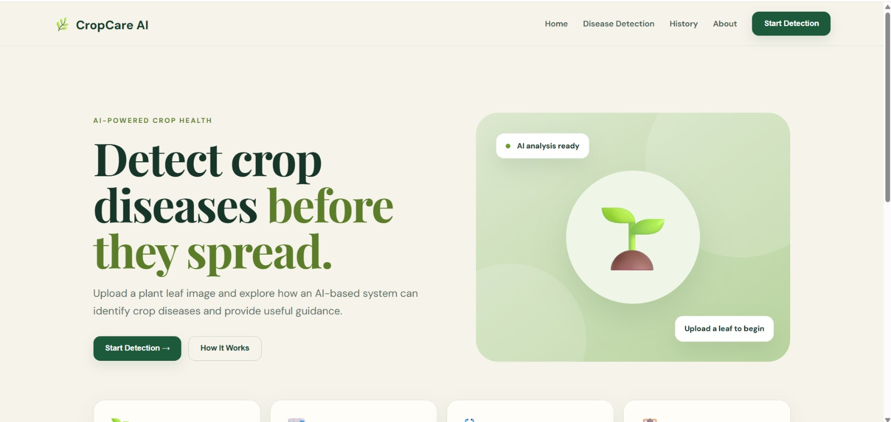
Figure 1. CropCare AI Home Interface

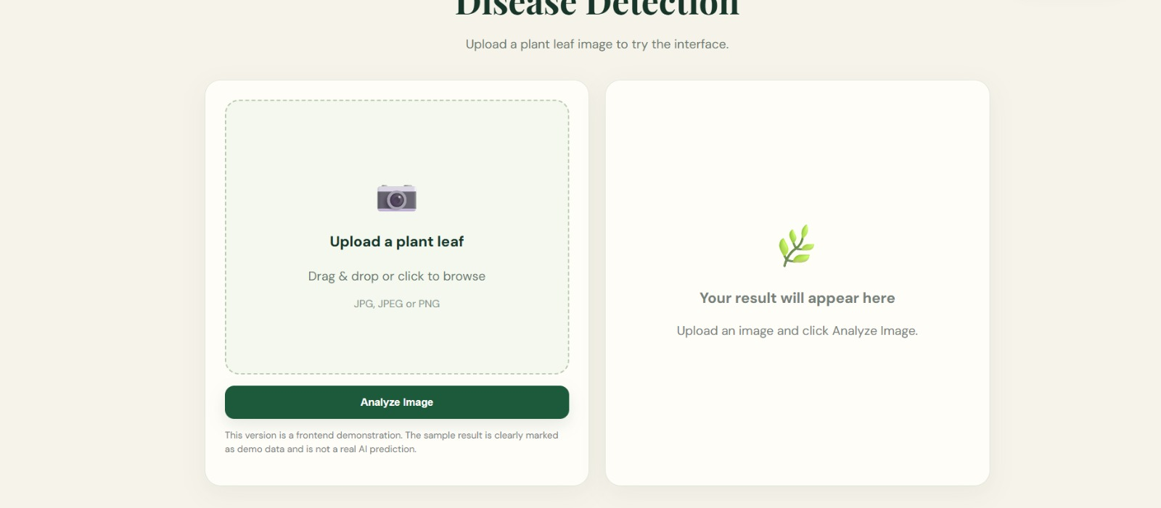
Figure 2. Disease Detection Upload Interface

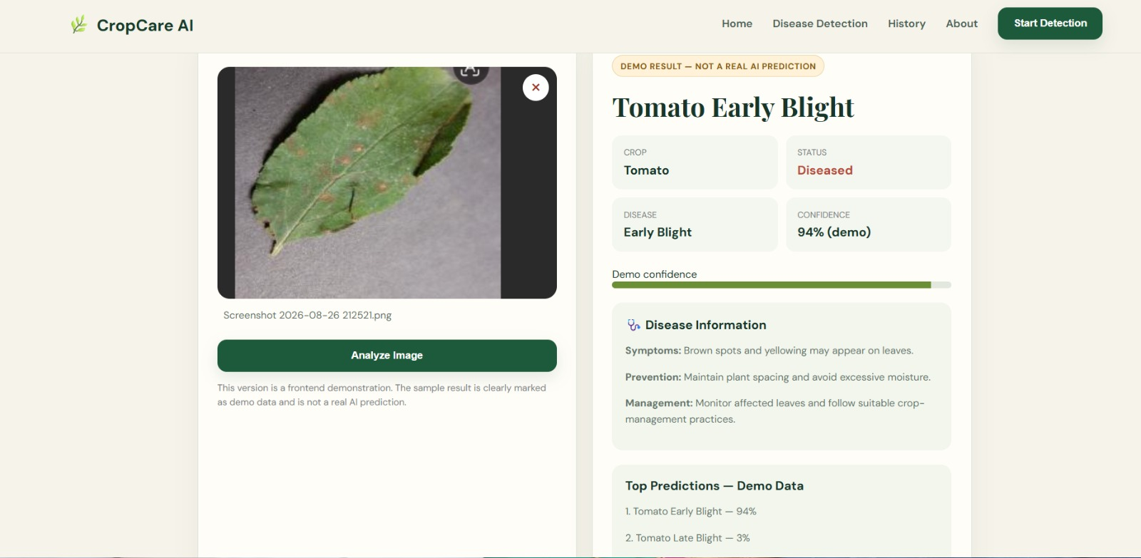
Figure 3. AI Disease Detection Result Interface

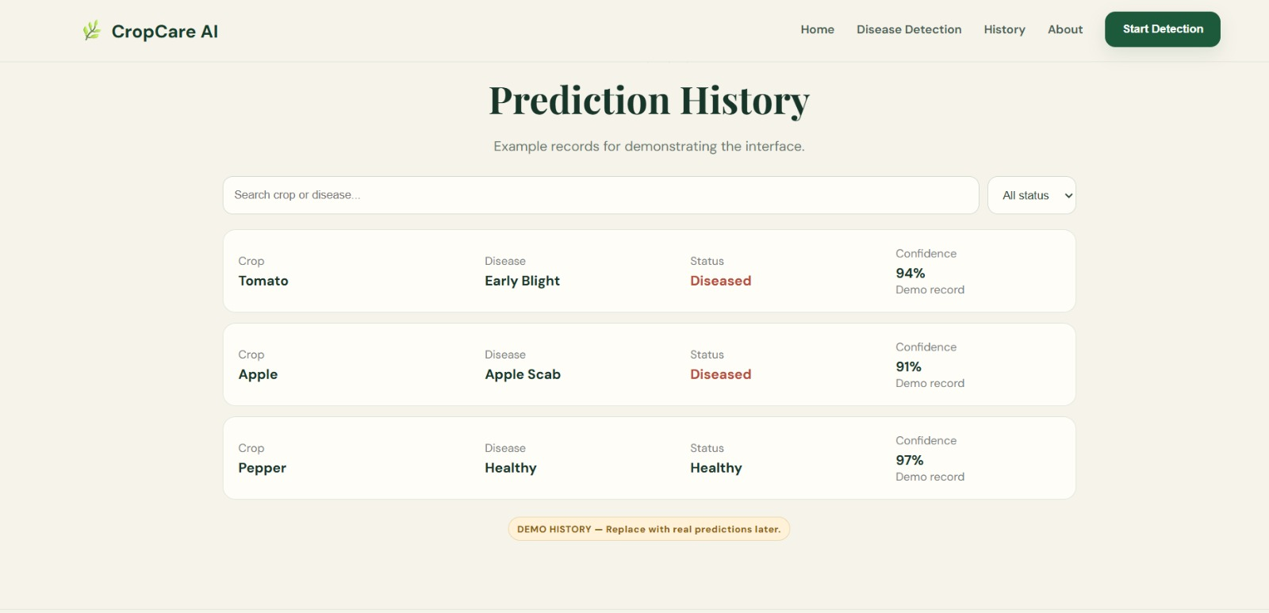
Figure 4. Prediction History Interface

4.3 Test Plan & Verification

Table 12. Test plan and verification
Requirement / Specification | Test Method | Acceptance Criterion | Achieved Value | Status
Image upload | Upload JPG/JPEG/PNG through UI | Image accepted and preview shown | Upload interface demonstrated | Pass
Analysis action | Click Analyze Image | Result panel appears | Result interface demonstrated | Pass
Disease result | Check predicted class, status and confidence | Fields displayed clearly | Tomato Early Blight, Diseased, 94% demo | Pass*
Disease information | Inspect result information panel | Symptoms/prevention/management shown | Displayed | Pass
Prediction history | Open History page | Previous records listed | Three demo records shown | Pass*
CNN model evaluation | Compare test metrics | Accuracy/precision/recall/F1 reported | 96.5/95.0/95.8/95.3% | Pass*

4.4 Results
The supplied evaluation chart reports the proposed CNN as the strongest model among the compared approaches. The web interface screenshots additionally demonstrate the intended application flow, including a sample Tomato Early Blight result with 94% demonstration confidence and a history page containing demonstration records.
Table 13. Model comparison results
Model | Accuracy (%) | Precision (%) | Recall (%) | F1-Score (%) | Training Time (s) | Model Size (MB)
CNN (Proposed) | 96.5 | 95.0 | 95.8 | 95.3 | 120 | 48
SVM | 88.3 | 86.1 | 87.2 | 86.6 | 300 | 15
Random Forest | 91.2 | 90.3 | 90.1 | 90.2 | 180 | 22
KNN | 78.6 | 76.5 | 77.1 | 76.8 | 250 | 12
Decision Tree | 69.4 | 67.8 | 68.3 | 68.0 | 80 | 5

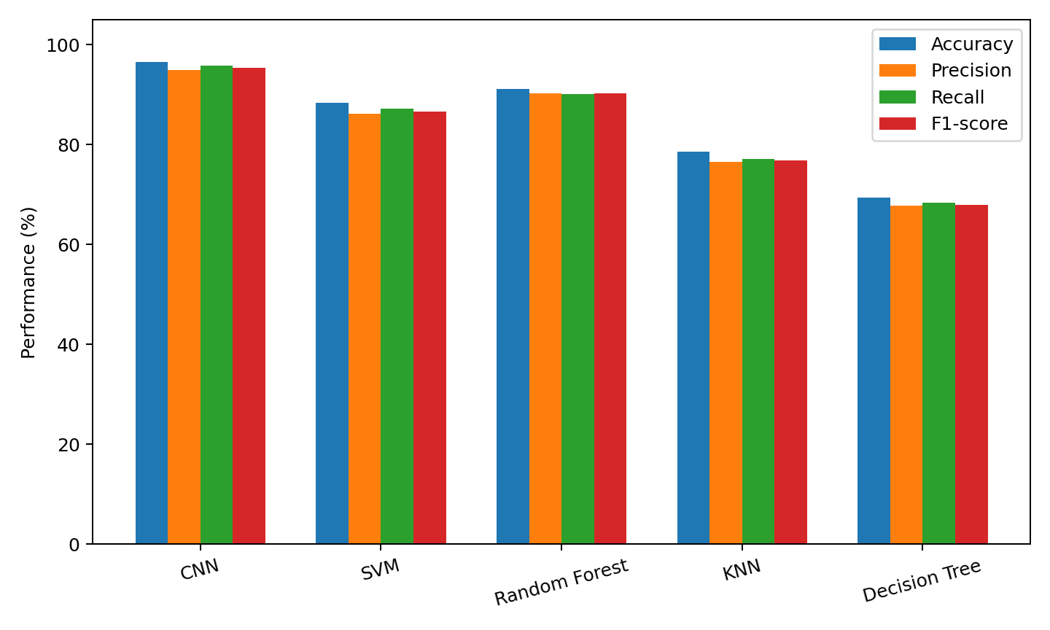
Figure 5. CNN Model Comparison and Evaluation Chart

4.5 Data Analysis & Engineering Judgment
The displayed metrics indicate that the CNN achieved the highest accuracy (96.5%) and F1-score (95.3%) among the five compared models. Its training time is higher than the Decision Tree and its model size is larger, illustrating a trade-off between predictive performance and computational/resource cost. The results therefore support the selection of CNN for the proposed prototype, while also indicating the need for validation on diverse real-world field images before deployment.

4.6 Comparison with Existing Solutions & Achievement of Objectives

Table 14. Achievement of project objectives
Objective | Evidence | Achievement
Develop AI disease detector | CNN model and integrated interface | Fully Achieved
Prepare image dataset | Training/validation dataset workflow | Achieved
Preprocess images | 128×128 resizing and 1/255 normalization | Achieved
Train AI classifier | Three convolution blocks + dense + softmax | Achieved
Evaluate performance | Accuracy, precision, recall, F1 comparison | Achieved
Provide user-friendly interface | Home, upload, result and history screenshots | Fully Achieved
Provide practical disease guidance | Result page contains symptoms/prevention/management | Achieved
Reduce dependence on manual screening | Automated image classification workflow | Partially Achieved – requires broader field validation

4.7 Strengths & Limitations
Strengths:
- High displayed CNN evaluation performance compared with the selected baseline models.
- Simple image-upload and result workflow.
- Disease information and prediction history improve usability.
- Modular workflow allows future extension to additional crops and diseases.
Limitations:
- The interface screenshots explicitly identify the displayed predictions as demo data.
- Performance may vary with field lighting, backgrounds, camera quality and disease severity.
- The system can only classify categories represented in the training dataset.
- Real-world field validation and larger, more diverse datasets are required before production use.

4.8 Project Planning, Roles & Budget
Table 15. Project milestones
Milestone | Planned Activity | Output
1 | Problem definition and literature review | Requirements and background
2 | Dataset preparation | Organized training/validation data
3 | Preprocessing and CNN design | Model pipeline
4 | Model training and evaluation | Performance metrics
5 | Interface development | CropCare AI prototype
6 | Testing and documentation | Final report and evidence

Table 16. Project roles and responsibilities
Student | Assigned Responsibility | Actual Contribution
S. Mythili | AI/model development | Dataset, preprocessing and CNN training
G. Bhavya | Application/interface development | Upload, result and history interface
S. Roobini | Testing/documentation | Evaluation, documentation and report preparation

Table 17. Project budget
Item | Estimated Cost (INR) | Actual Cost (INR)
Existing laptop/computer | 0 | 0
Open-source software/libraries | 0 | 0
Dataset resources | 0 | 0
Internet / cloud experimentation | 500 | 500
Documentation/printing | 500 | 500
Total | 1000 | 1000

CHAPTER 5
CONCLUSION, FUTURE WORK AND REFLECTION
5.1 Conclusion
The project addressed the problem of slow and potentially inconsistent crop disease identification by developing an AI-based image classification workflow. The proposed system combines crop-leaf image input, preprocessing, CNN-based classification, evaluation, and a user-friendly interface. The supplied model comparison reports 96.5% accuracy, 95.0% precision, 95.8% recall, and 95.3% F1-score for the proposed CNN, which is higher than the displayed baseline models. The interface evidence demonstrates the intended upload, analysis, disease-information, and history workflow. Because the interface labels sample outputs as demo data, broader field validation remains necessary before claiming production-level performance.

5.2 Future Work
- Expand the dataset to cover more crop types, disease classes, geographic conditions and real field images.
- Introduce disease-severity estimation for early, moderate and severe infection stages.
- Develop a mobile application for direct smartphone image capture.
- Integrate IoT sensors for environmental monitoring such as temperature and humidity.
- Use cloud infrastructure for scalable inference, storage and continuous model updating.
- Add explainable-AI features to help users understand why a disease class was predicted.
- Provide localized crop-management recommendations with expert validation.

5.3 Professional Learning & Individual Reflection

S. Mythili – Reflection
I gained practical knowledge of dataset preparation, image preprocessing and CNN model training. The most difficult part was organizing image data and maintaining a consistent input format. I learned that model performance depends strongly on dataset quality and validation. If I repeated the project, I would include more diverse field images and stronger augmentation.

G. Bhavya – Reflection
I developed practical understanding of integrating an AI workflow with a user-facing application. Designing a simple upload-and-result interaction showed me the importance of usability in AI systems. I also learned to present model output clearly instead of exposing unnecessary technical complexity. I would improve the interface further for mobile users and accessibility.

S. Roobini – Reflection
I improved my skills in testing, result comparison, documentation and technical communication. Comparing CNN with traditional models helped me understand engineering trade-offs between accuracy, training time and model size. I learned that limitations must be reported honestly, especially when interface results are demonstration data. I would strengthen the project through wider field testing and independent validation.

5.4 New Knowledge and Professional Skills
The project strengthened knowledge in artificial intelligence, machine learning, computer vision, image preprocessing, CNN architecture, model evaluation, web interface integration, testing, documentation, teamwork, and engineering decision-making.

5.5 Overall Reflection
The capstone provided experience in transforming an agricultural problem into an AI engineering workflow. It demonstrated that an effective solution requires more than a high model score: dataset quality, usability, risk, ethical communication, computational cost, and real-world validation must also be considered.

REFERENCES
- Abade, A., Ferreira, P. A., & de Barros Vidal, F. (2021). Plant diseases recognition on images using convolutional neural networks: A systematic review. Computers and Electronics in Agriculture, 185, 106125.
- Gao, R., Wang, R., Feng, L., Li, Q., & Wu, H. (2021). Dual-branch, efficient, channel attention-based crop disease identification. Computers and Electronics in Agriculture, 190, 106410.
- Kendler, S., Aharoni, R., Young, S., Sela, H., Kis-Papo, T., Fahima, T., & Fishbain, B. (2022). Detection of crop diseases using enhanced variability imagery data and convolutional neural networks. Computers and Electronics in Agriculture, 193, 106732.
- Li, P., Jing, R., & Shi, X. (2022). Apple disease recognition based on convolutional neural networks with modified Softmax. Frontiers in Plant Science, 13, 820146.
- Jung, M., Song, J. S., Shin, A.-Y., Choi, B., Go, S., Kwon, S.-Y., Park, J., Park, S. G., & Kim, Y.-M. (2023). Construction of deep learning-based disease detection model in plants. Scientific Reports, 13, 7331.
- Pal, C., Karmakar, S., Mukherjee, I., & Chakrabarti, P. P. (2025). A lightweight and explainable CNN model for empowering plant disease diagnosis. Scientific Reports, 15, 30720.
- Pai, P., Amutha, S., Patil, S., Shobha, T., Basthikodi, M., Shafeeq, B. M. A., et al. (2025). Deep learning-based automatic diagnosis of rice leaf diseases using ensemble CNN models. Scientific Reports, 15, 27690.
- Sahu, K., Tiwari, S., Singh, M. K., Pahareeya, J., Shakya, H. K., Kumar, G. K., et al. (2025). Plant disease detection using a hybrid dilated CNN with attention mechanisms and optimized Mask R-CNN segmentation. Scientific Reports, 15, 42008.
- Devarajan, D., Allafi, R., Obayya, M., et al. (2026). AI based real time disease diagnosis in plants using deep learning driven CNNs. Scientific Reports, 16, 4587.
- Muthu, B., & Cherubini, C. (2026). A novel approach for crop disease detection using transfer-learning-based deep convolutional neural networks. Neural Computing and Applications, 38, 500.

APPENDICES

Appendix A – CNN Training Source Code
import tensorflow as tf
from tensorflow.keras import layers, models

dataset_path = "dataset"

train_data = tf.keras.utils.image_dataset_from_directory(
dataset_path,
validation_split=0.2,
subset="training",
seed=123,
image_size=(128, 128),
batch_size=32
)

val_data = tf.keras.utils.image_dataset_from_directory(
dataset_path,
validation_split=0.2,
subset="validation",
seed=123,
image_size=(128, 128),
batch_size=32
)

class_names = train_data.class_names

normalization = layers.Rescaling(1./255)

model = models.Sequential([
normalization,
layers.Conv2D(32, (3,3), activation="relu"),
layers.MaxPooling2D(),

layers.Conv2D(64, (3,3), activation="relu"),
layers.MaxPooling2D(),

layers.Conv2D(128, (3,3), activation="relu"),
layers.MaxPooling2D(),

layers.Flatten(),
layers.Dense(128, activation="relu"),
layers.Dense(len(class_names), activation="softmax")
])

model.compile(
optimizer="adam",
loss="sparse_categorical_crossentropy",
metrics=["accuracy"]
)

history = model.fit(
train_data,
validation_data=val_data,
epochs=10
)

model.save("crop_disease_cnn.h5")
print("CNN training completed!")

Appendix B – Interface Evidence

Home page showing CropCare AI branding, navigation and Start Detection action.


Disease Detection page showing leaf-image upload and analysis controls.


Result page showing Tomato Early Blight demo output, disease information and confidence.


Prediction History page showing demonstration records for Tomato, Apple and Pepper.

Appendix C – Model Evaluation Data
Table 18. Evaluation dataset reported in the supplied project report
Model | Accuracy | Precision | Recall | F1 | Training Time (s) | Model Size (MB)
CNN | 96.5% | 95.0% | 95.8% | 95.3% | 120 | 48
SVM | 88.3% | 86.1% | 87.2% | 86.6% | 300 | 15
Random Forest | 91.2% | 90.3% | 90.1% | 90.2% | 180 | 22
KNN | 78.6% | 76.5% | 77.1% | 76.8% | 250 | 12
Decision Tree | 69.4% | 67.8% | 68.3% | 68.0% | 80 | 5

Appendix D – Capstone Project Outcome Mapping Sheet
Table 19. Capstone project outcome mapping
Outcome | Evidence / Location
Complex engineering problem formulation | Chapter 1 and Chapter 2
Engineering design under constraints | Chapter 3
Technical communication | Whole report and Viva
Ethics and professional responsibility | Chapter 3, Section 3.7
Teamwork and leadership | Chapter 4, Section 4.8
Experimentation, analysis and engineering judgment | Chapter 4, Sections 4.3–4.6
Independent acquisition of new knowledge | Chapter 5, Section 5.3
Standards | Chapter 3, Section 3.2
Sustainability and societal/environmental impact | Chapter 3, Section 3.7
Risk assessment and mitigation | Chapter 3, Section 3.7
Security considerations | Chapter 3, Section 3.7
Integrated/system-level engineering | Chapter 3, Section 3.5
Project planning and management | Chapter 4, Section 4.8
Individual contribution | Contribution Statement and Chapter 4, Section 4.8

